Project SEARCH with ASD Supports:
A Randomized Clinical Trial to Explore Competitive Employment for 18 to 22 Year-Olds with Autism Spectrum Disorders (ASD)

In the first randomized clinical trial to test the effectiveness of a transition to employment treatment model for youth with ASD, a study from Virginia Commonwealth University reported youth with autism between the ages of 18 to 22 achieved employment at 87% in Project SEARCH with Autism Supports, while a control group only achieved employment at 6%. Previous studies have shown that, despite intensive intervention in special education programs, youth
with ASD have poor outcomes related to employment upon graduation from high school. In fact, unemployment and underemployment is a chronic problem for youth with ASD, with unemployment rates varying from 80% to 95%. These findings of poor employment outcomes hold across the spectrum of abilities for youth with ASD. Further, youth with ASD have lower rates of participation in post-secondary education and Vocational Rehabilitation service providers have struggled to provide services to these youth with ASD. Finally, there has been little research to date to provide guidance to high school and adult service providers seeking to assist youth with ASD in acquiring and maintaining employment.
Project SEARCH is an intensive 9-month job training program where youth with developmental disabilities in their last year of high school are embedded in a large community business, such as a hospital, government complex, or banking center. Students with developmental disabilities who participate in this model rotate through three 10-12 week internships within the business, where they log approximately 720 hours of internship time learning marketable skills and 180 hours
of classroom time at the business for a total of approximately 900 embedded hours.
In addition to these important training components, Project SEARCH requires collaboration between multiple community partners to support youth in attaining employment upon completion of the program. This project is a collaborative model

Author: Carol Schall, Ph.D. September 2013
Rehabilitation Research and Training Center
between students with developmental disabilities and their family members, a local education agency (LEA), a local community rehabilitation program (CRP), the state vocational rehabilitation program (VR), and a

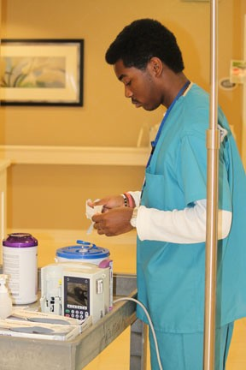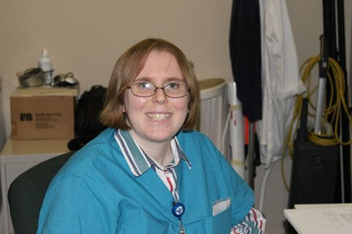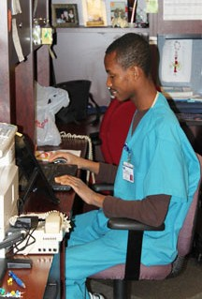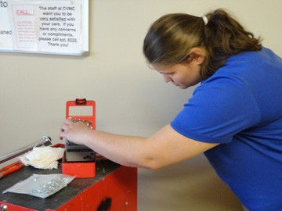host business. The student and family members identify
their personalized employment goals and participate in voca- tional assessments and internships. The LEA provides a teacher and an adequate number of instructional assistants to implement the senior year IEP of student interns in the program. The state VR provides funding and supervision for job coaching services that are provided throughout the final year of school in the internships. The CRP provides job coaches to assess student interests, develop and

supervise internships, and provide on-site job coaching during the school day. Finally, the business provides internship sites in high need, high turnover positions.
Project SEARCH

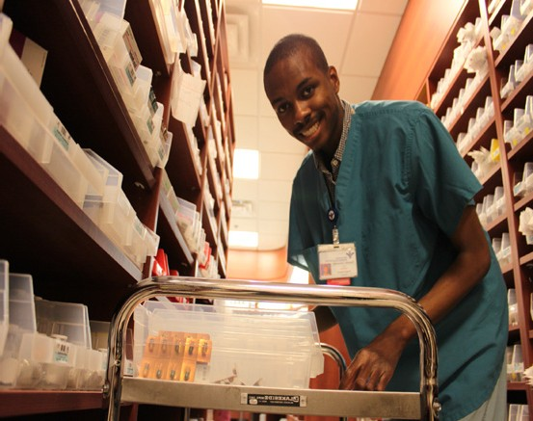In this study, Researchers from Virginia Commonwealth University, Rehabilitation Research and Training Center and Autism Center for Excellence partnered with Bon Secours Health System, St. Mary’s Hospital in Henrico, Virginia and St. Francis Hospital in Chesterfield, Virginia; Henrico County Public Schools; Chesterfield County Public Schools; and the Virginia Department of Aging and Rehabilitation Services to carry out the research.

In addition, in order to meet the unique needs of youth with ASD, the research team enhanced the Project SEARCH model by adding autism supports to the original model. More specifically, the ASD supports that were added to the Project SEARCH Model for this research included:

- on-site, intensive, systematic instruction using the principles of applied behavior analysis,
- on-site support and consultation from a behavior/autism specialist, and
- intensive staff training in ASD and the Project SEARCH Model.

Research Method This study took place between 2009 and 2012. A total of 70 high
school students between the ages of 18 to 22 applied to participate in the project. Twenty-six
of those students did not meet the inclusion criteria leaving 44 eligible students. These 44 youth between the ages of 18 and 21, with a medical diagnosis or educational eligibility of Autism, Pervasive Developmental Disorder-Not Otherwise Specified, or Asperger’s Disorder, were randomly assigned to one of two groups:
  - the treatment group: Project SEARCH plus ASD Supports and
  - the control group: students attended their assigned high schools and received services as stipulated in their Individualized Education Programs (IEPs).

Four students, who were randomly assigned to the control group, dropped out prior to initiation of the study leaving a total 40 students participating in the study. The students in the treatment group received a full year of exposure to Project SEARCH plus Supports
for students with ASD (Wehman, Schall, et al., 2013) in their final year of high school. The control group received education in their home high school and followed their individualized education programs.

After the attrition of 4 students in the control group, a total of 40 students were randomized into the study. Sixteen students were placed in the control group and the remaining 24 in the treatment group. The control and treatment groups were equivalent on a number of demographic variables including race, gender, medical diagnosis, and IEP service category.
There was a significant difference [(t (38) = 2.359, p = 0.024] between the ages of the treatment (m = 19.97 years, sd = 1.09) and control groups (m = 19.13 years, sd = 1.09). The ages for both groups ranged from 18 years old to 21.5 years old and the mean difference between these two groups was slightly less than 10 months.
The hypotheses driving this study were: 1) Individuals who participate in an employer-
based employment training and placement program will be employed at a higher rate than those in the control condition at:

    - 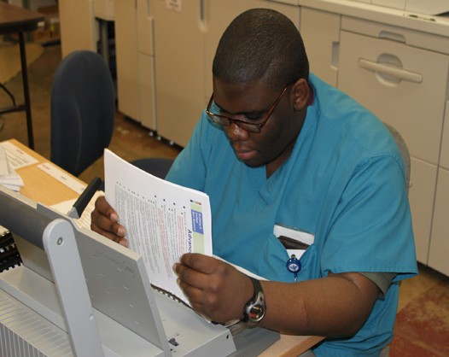completion of intervention (Time 2) and
    - three months post completion of the intervention (Time 3). Hours worked, hourly wage, and paid benefits will be explored
to further understand the employment characteristics of students with ASD obtaining employment.

- Individuals who participate in an employer- based employment training and placement program will require less work support as measured by the Support Intensity Scale Employment Activities Sub-scale (Thompson, et al., 2004a) than those in the control condition at:
  - completion of intervention (Time 2) and
  - three months post completion of the intervention (Time 3).

Employment Upon entry into the study, there were no differences between the treatment and control
Outcomes groups on prior work experience or intensity of general support needs. There were significant differences between the two groups on behavioral and medical support needs, with the
treatment group reportedly displaying more behavioral challenges and having more co- occurring medical needs.

After nine months in the Project SEARCH plus ASD Supports program, however, 21 of 24 (87%) students in the treatment group gained competitive employment in jobs not traditionally considered for individuals with developmental disabilities, while only 1 of 16 (6%) control group students gained competitive employment. Additionally, treatment group students who were employed earned an hourly wage that was approximately 24% higher than minimum wage and worked between 20 to 40 hours per week. The one student that was employed from the control group declined to share the wages earned, or hours worked, so it was not possible to compare the two groups on these characteristics. All 21 treatment group students who were employed maintained their employment 3 months post graduation.
Interestingly, there is evidence from the current study that employment acts as a “therapeutic” factor for young adults with ASD. At baseline, no difference was indicated between the control group mean support score of 8.33 and the treatment group mean support score of 8.74.
Upon graduation, the control group reported a slight increase in employment support intensity with a mean support score of 8.36, while the treatment group showed a slight decrease with their mean score of 8.23. By three months out, however, there was a significant difference between the treatment (m = 7.65) and control (m = 8.58) group mean standard scores on
the Employment Activities Subscale of the SIS. Given that the intensity of support needs appeared to decrease over this short of a period for the treatment group, it appears that even 3 months of employment after an intensive internship transition program could prove to be therapeutic. In addition to achieving employment at a statistically higher rate, participants in the treatment group also achieved employment in competitive jobs that have not traditionally been considered for youth with ASD. For example, these youth attained employment in departments such as the Intensive Care Unit, Surgical Services, Central Sterile Services, Durable Medical Equipment, and Coronary Care Unit.

Findings This study yielded a number of important findings for youth with ASD, their parents, teachers, and support providers:

- - Youth with ASD can be successful at work in non-traditional jobs after an intensive 9-month internship program.
- - It appears that these youth with ASD achieved a seamless transition from high school to work due to the supports in the program, as well as the combined provision of services during the program.
- - These youth maintained employment for three months and beyond.
- - As the hospital supervisors and administrators became acquainted with the youth with ASD, they became champions for the students as employees.
Additionally their initial fears were allayed by the contribution that the youth with ASD made to their departments.
- - The families of these youths moved from disbelief that their sons and daughters could work to fully supportive of their newfound independence at work.
- - This intervention demonstrated the power of collaborative funding streams for youth with ASD in transition to adulthood.
It appears that there were three elements that lead to these outcomes in the treatment condition. They were collaboration between the business, LEA, VR, and CRP in the provision of services, training for staff in ASD and employment supports, and the provision of ASD specific supports. These three factors likely contributed to the success of the intervention.

Conclusion This paper presented the preliminary results of a randomized clinical trial of Project SEARCH plus ASD Supports on the employment outcomes for youth with ASD between the ages of 18 to 21 years of age. For most youth with ASD, employment upon graduation from high school
or college is elusive. This model provides very promising results in that the employment outcomes for youth in the treatment group were much higher in non-traditional jobs with higher than minimum wage incomes than for youth in the control condition. Specifically, 21 out of 24 (87.5%) treatment group participants acquired employment while 1 of 16 (6.25%) of control group participants acquired employment. This study provides compelling evidence
that employment upon graduation from high school is achievable for youth with ASD who also display challenging behavior and have co-morbid medical diagnoses.

Additional Wehman, P. H., Schall, C. M., McDonough, J., Kregel, J., Brooke, V., Molinelli, A., Ham, W., Information Graham, C. W., Riehle, J. E., Collins, H. T., & Thiss, W. (2013). Competitive employment for youth with Autism Spectrum Disorders: Early results from a randomized clinical trial. Journal
of Autism and Developmental Disorders DOI 10.1007/s 10803-013-1892-x
For more information please contact: Carol Schall -- cmschall@vcu.edu You can also visit our website at: http://www.vcu-autism.org/about/index.cfm

The contents of this flyer were developed under a grant from the Disability and Rehabilitation Research Project (DRRP) grant #H133B080027 from the National Institute on Disability and Rehabilitation Research (NIDRR). Virginia Commonwealth University, School of Education and Department of Physical Medicine and Rehabilitation is an equal opportunity/affirmative action institution providing access to education and employment without regard to age, race, color, national origin, gender, religion, sexual orientation, veteran’s status, political affiliation, or disability. If special accommo- dations are needed, please contact Jennifer McDonough at (804) 828-1851 VOICE or (804) 828-2494 TTY.
Project SEARCH

